**Solution Screenshots Document**

1. **As Is Workflow:**

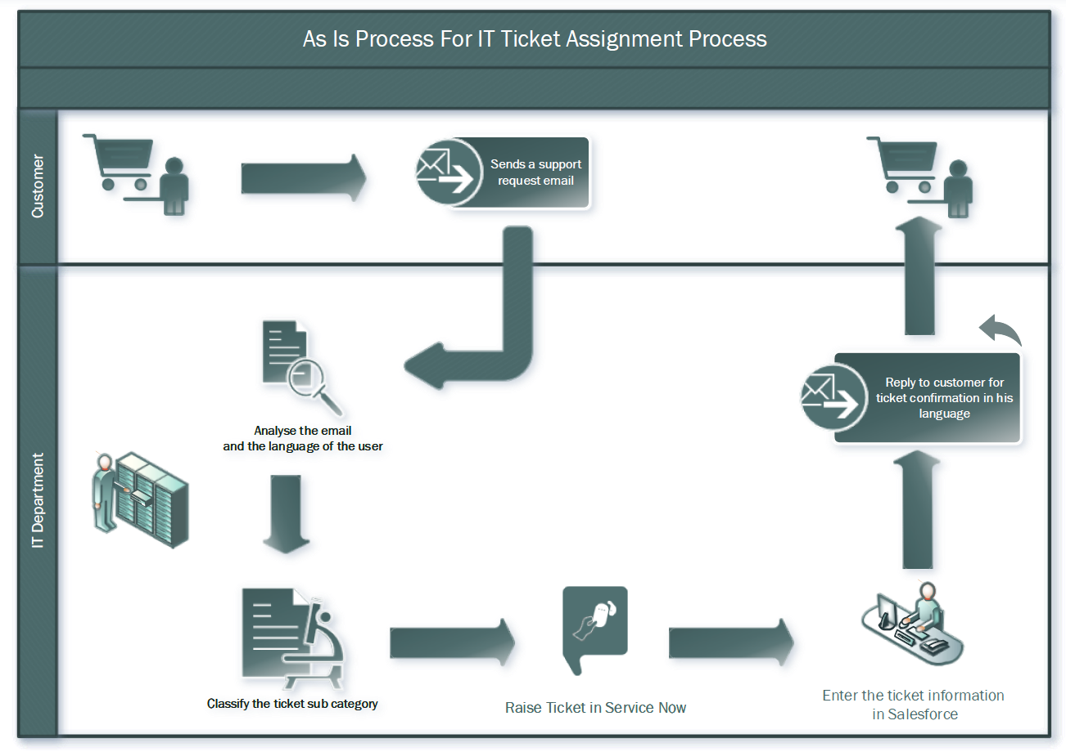

1. **To Be Workflow:**

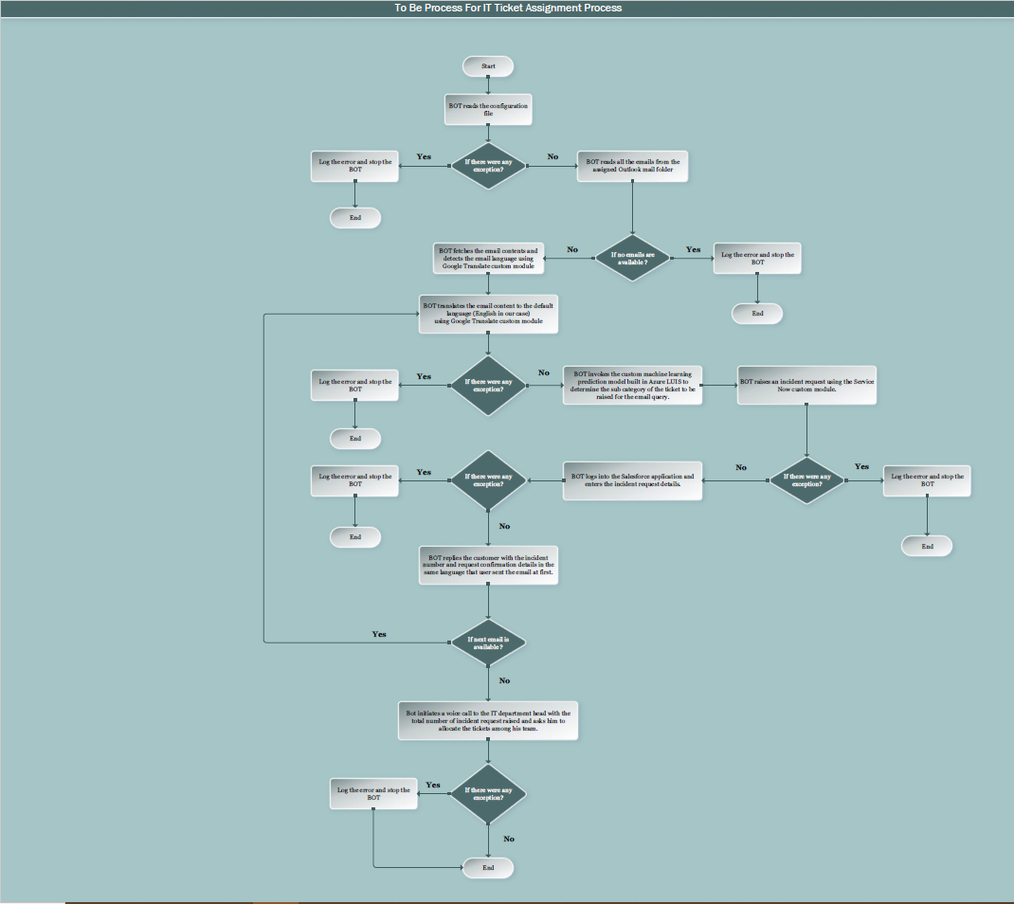

1. **Solution Flowchart:**

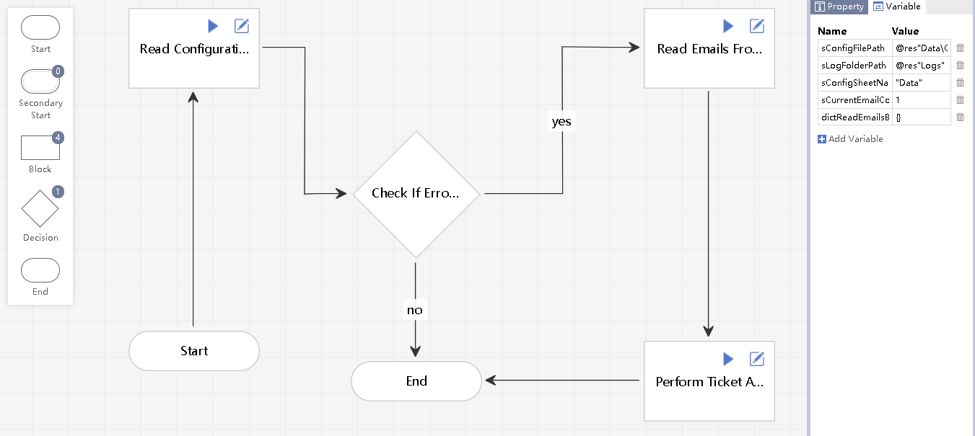

1. **Read Configuration File Task:**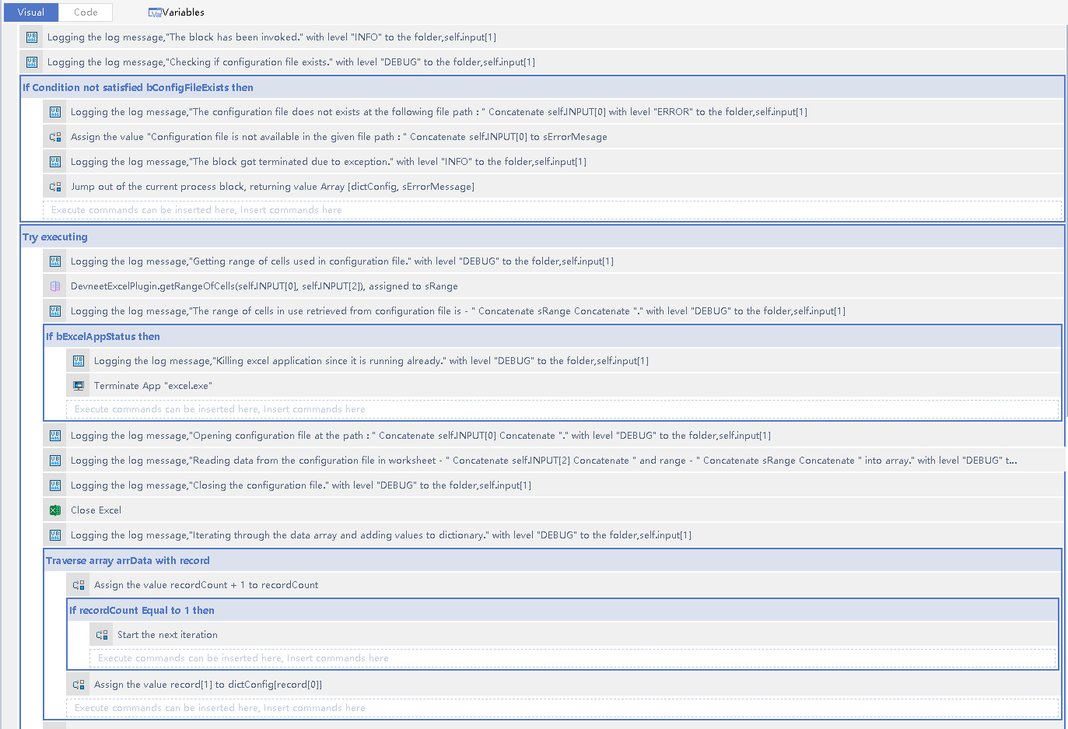

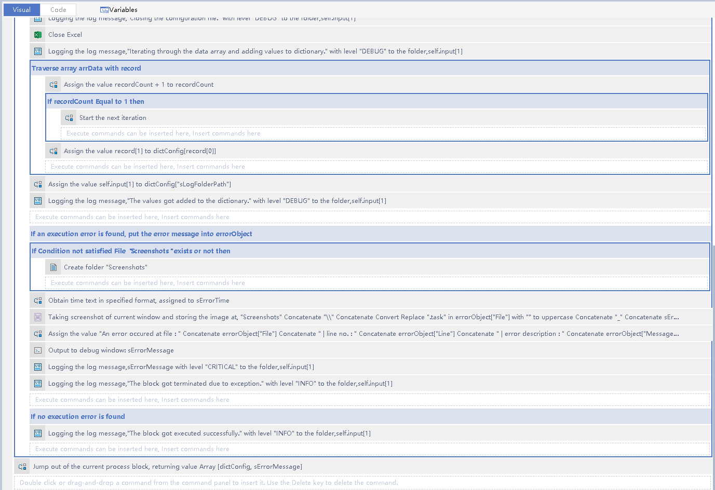

1. **Read Emails From Outlook Folder:**

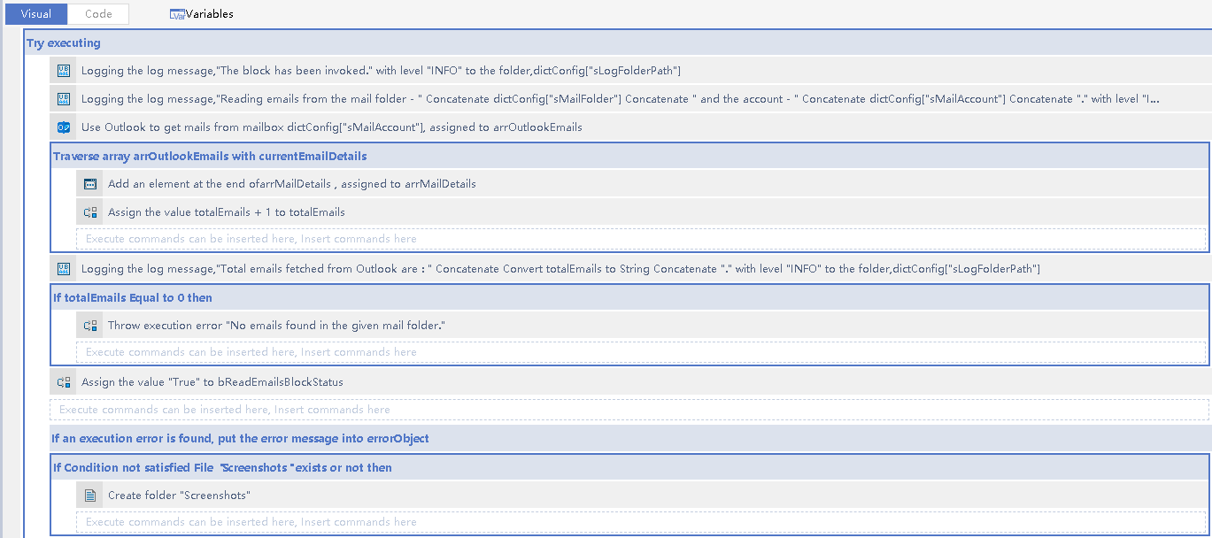

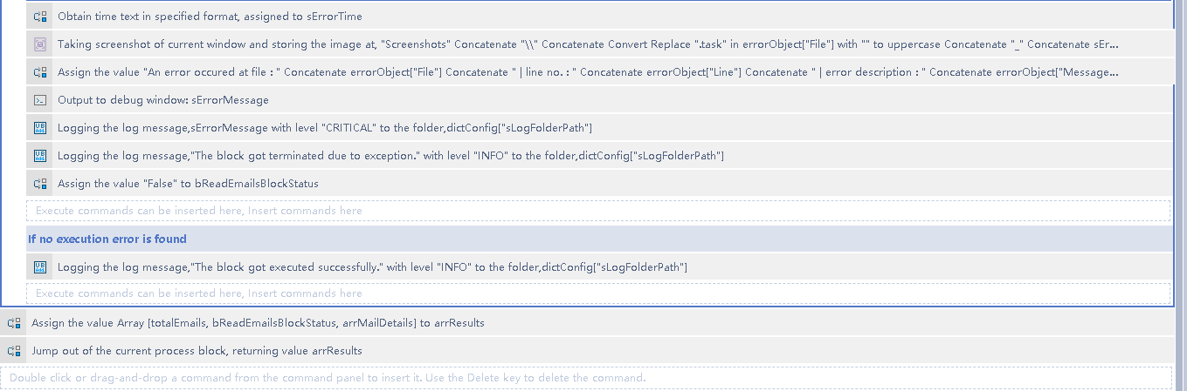

1. **Perform Ticket Analysis:**

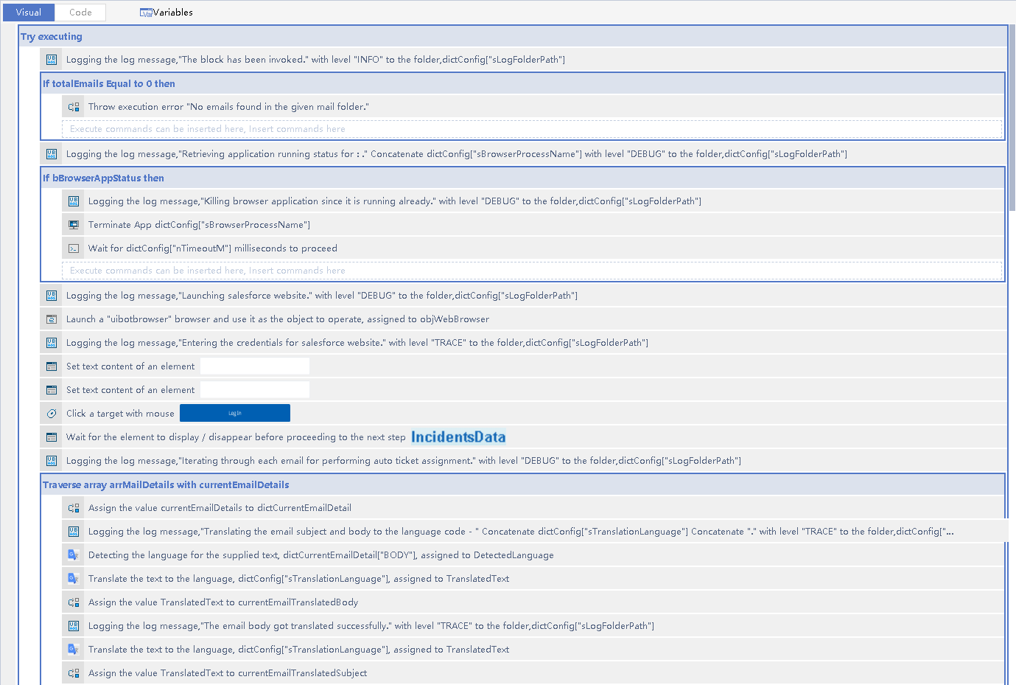

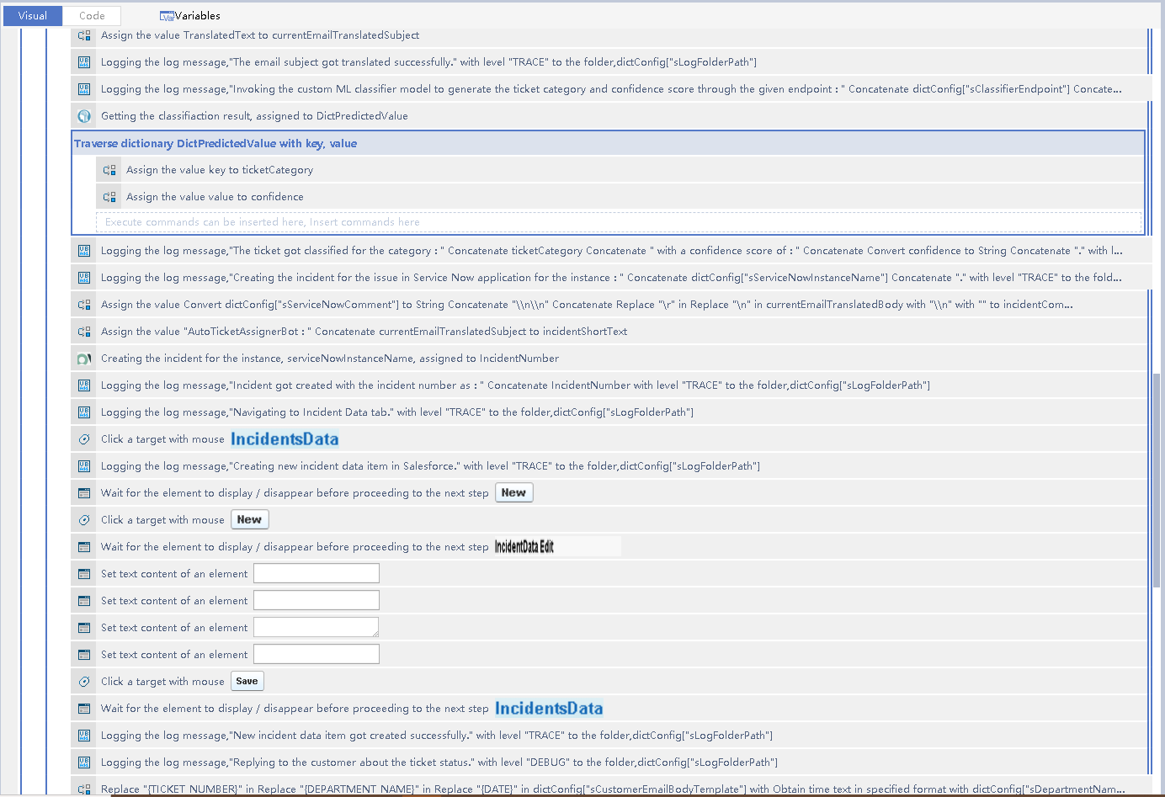

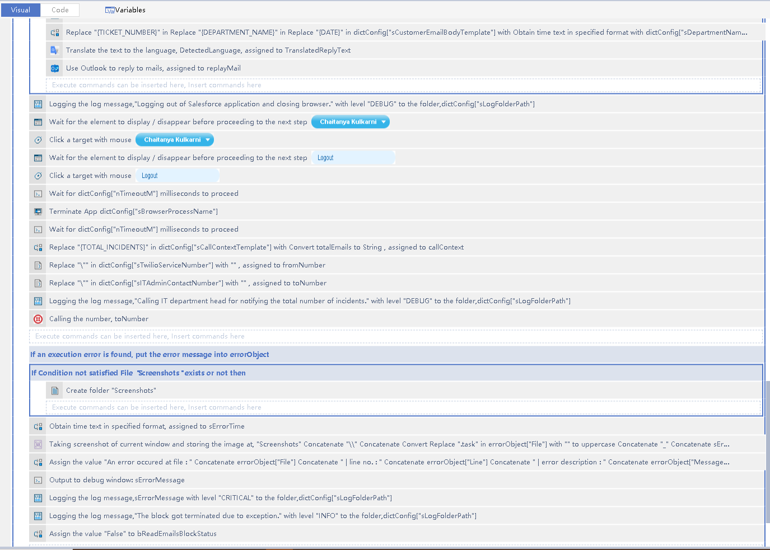 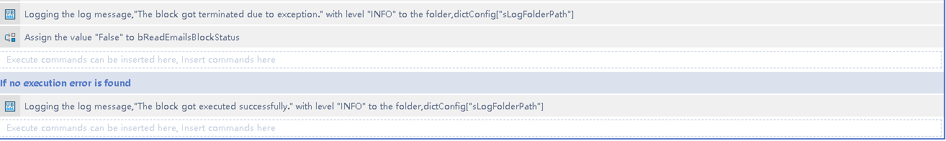

1. **Custom Modules Built:**

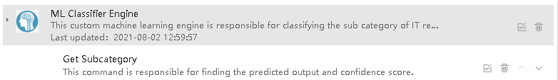

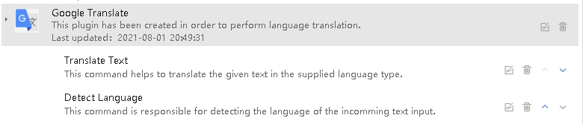

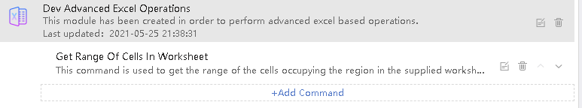

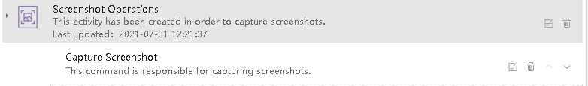

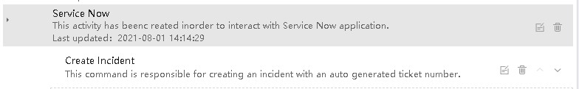

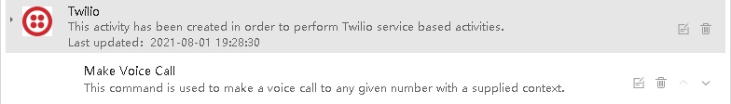

1. **Azure LUIS Cognitive ML Model Dashboard:**

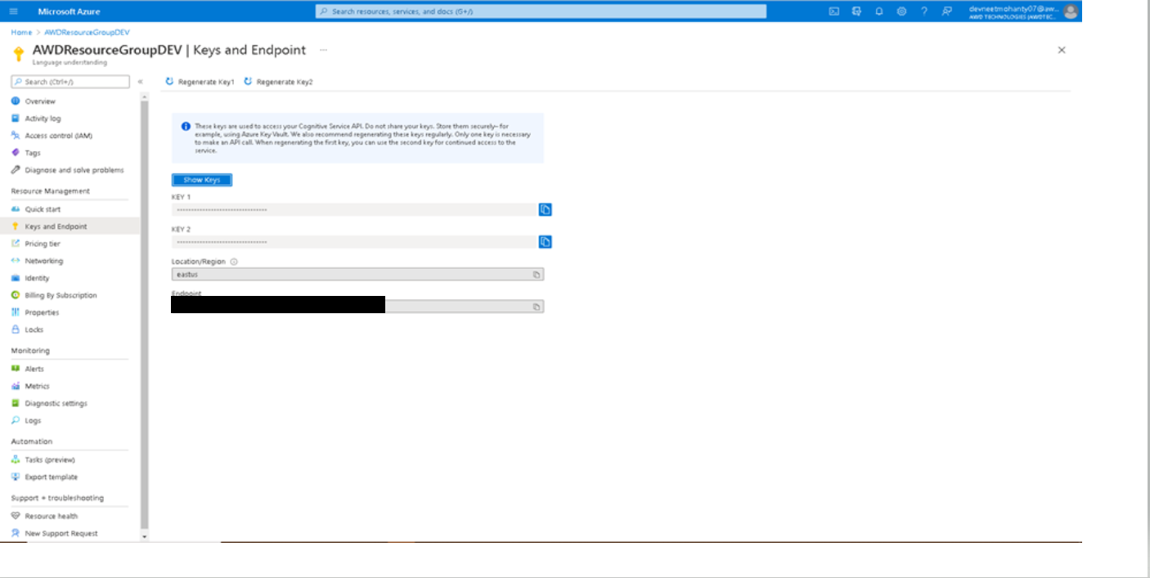

1. **Azure LUIS Cognitive ML Model API Call Metric:**

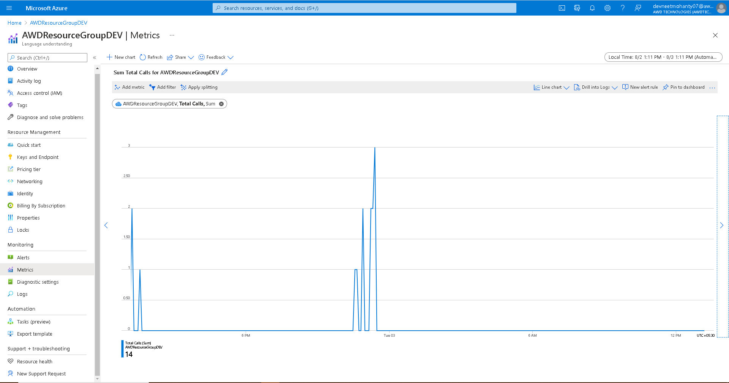

1. **Configuration File For Robot:**

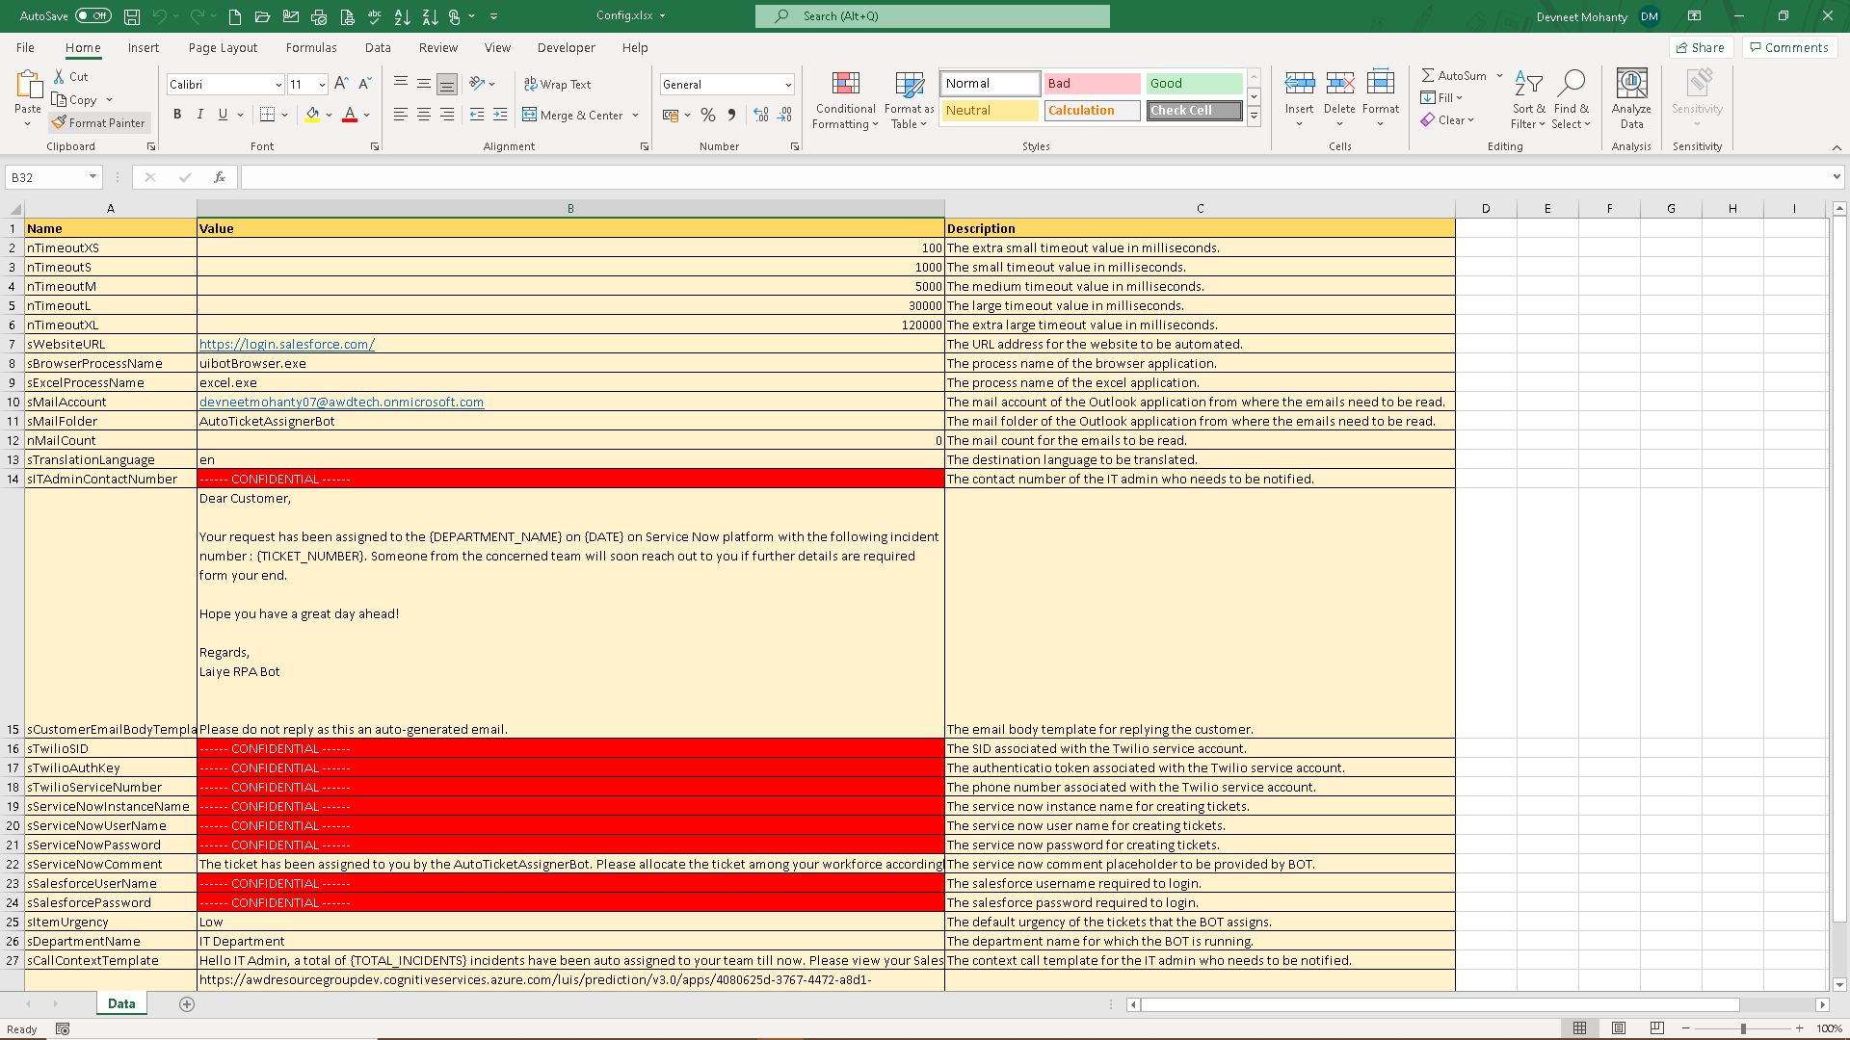

1. **Robot Resources Folder:**

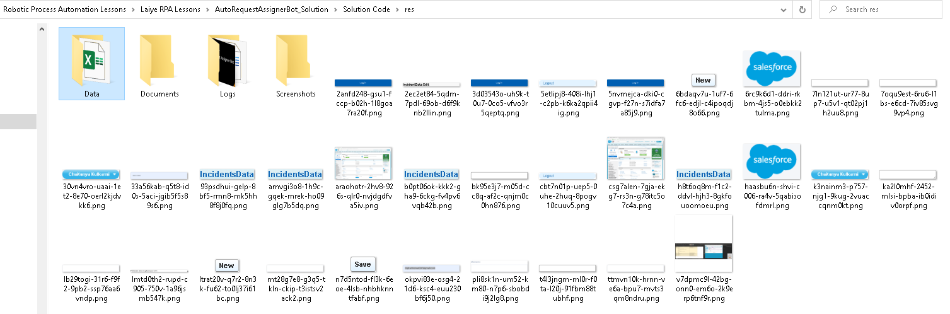

1. **Robot Plugin Folder:**

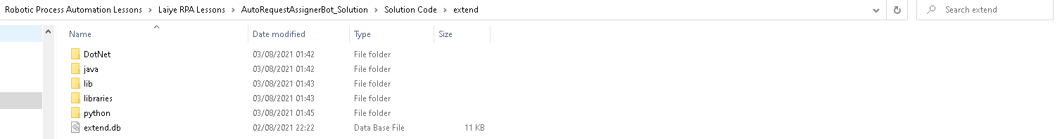 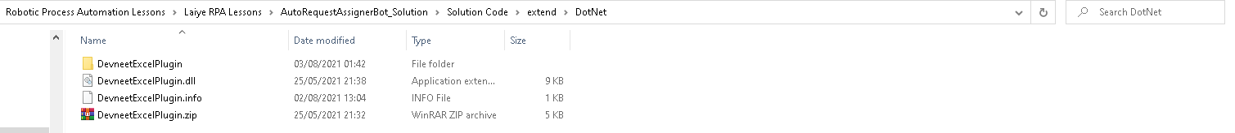 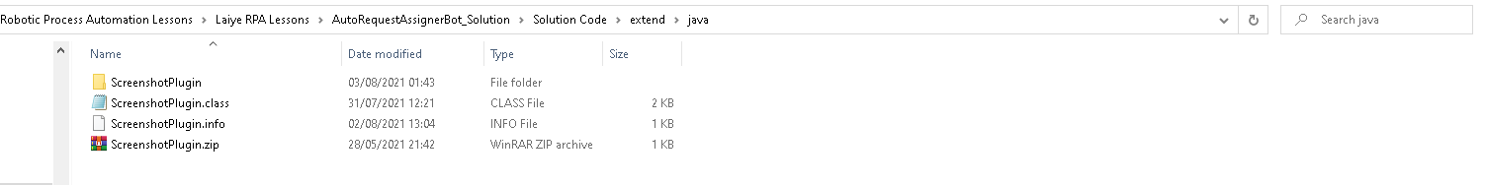 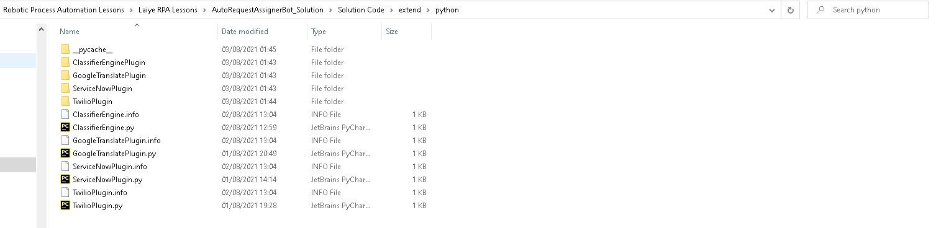 

1. **Twilio Dashboard:**

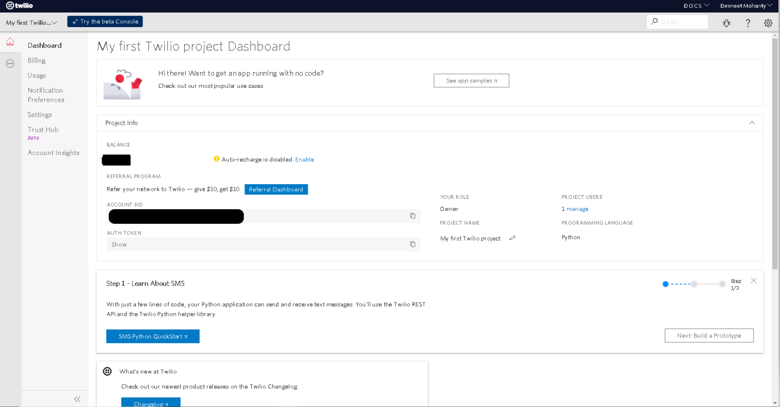

1. **Input Emails:**

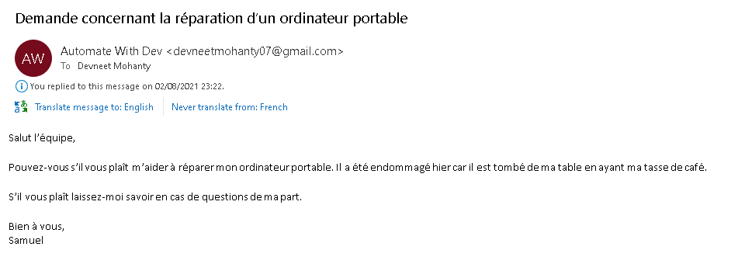

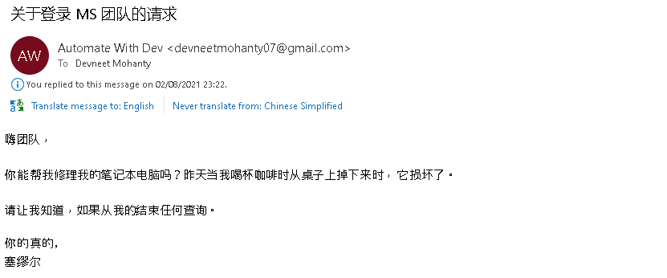

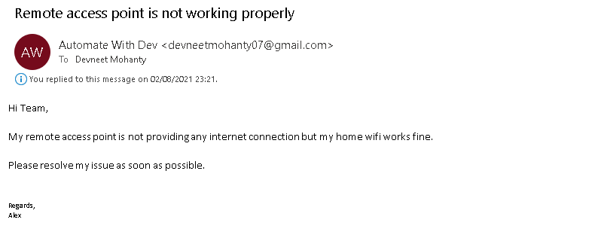

1. **Post Successful Run – Logs:**

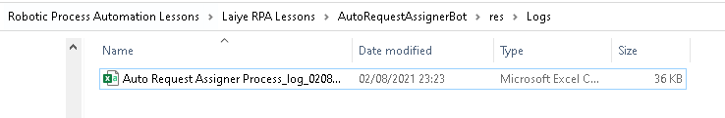

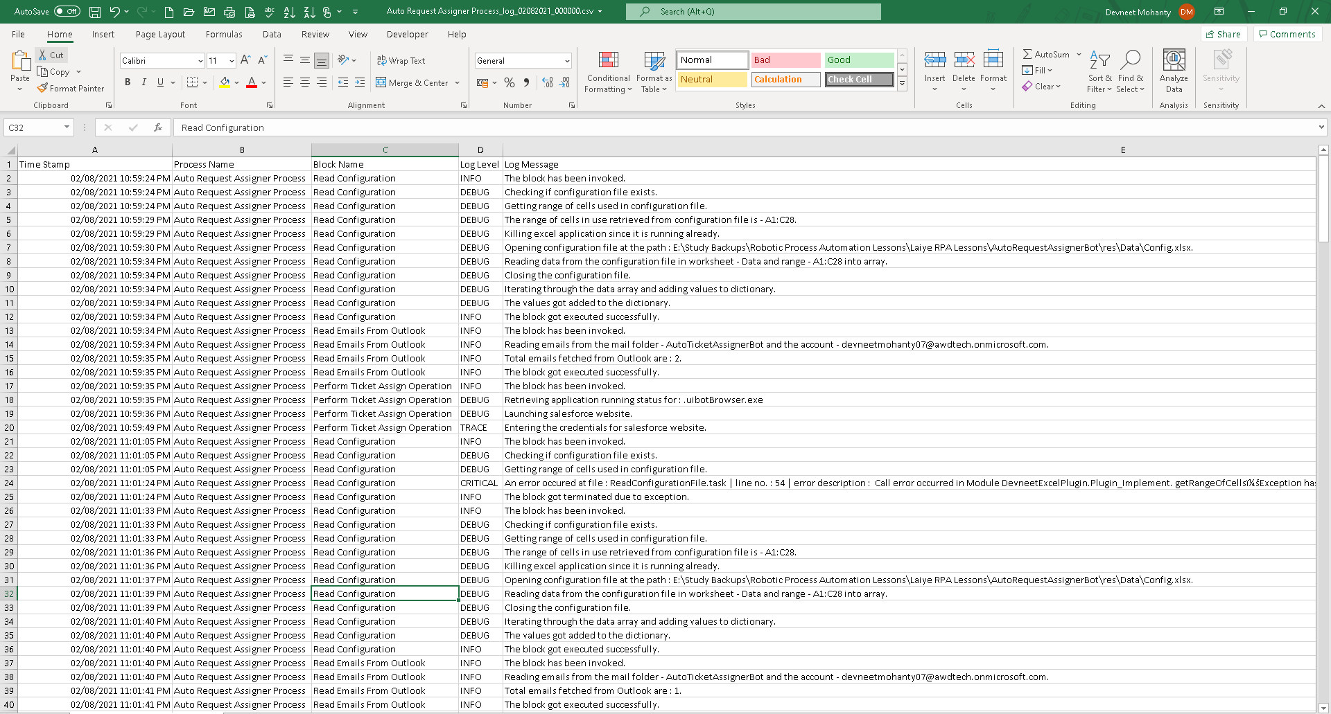

1. **Post Successful Run – Service Now:**

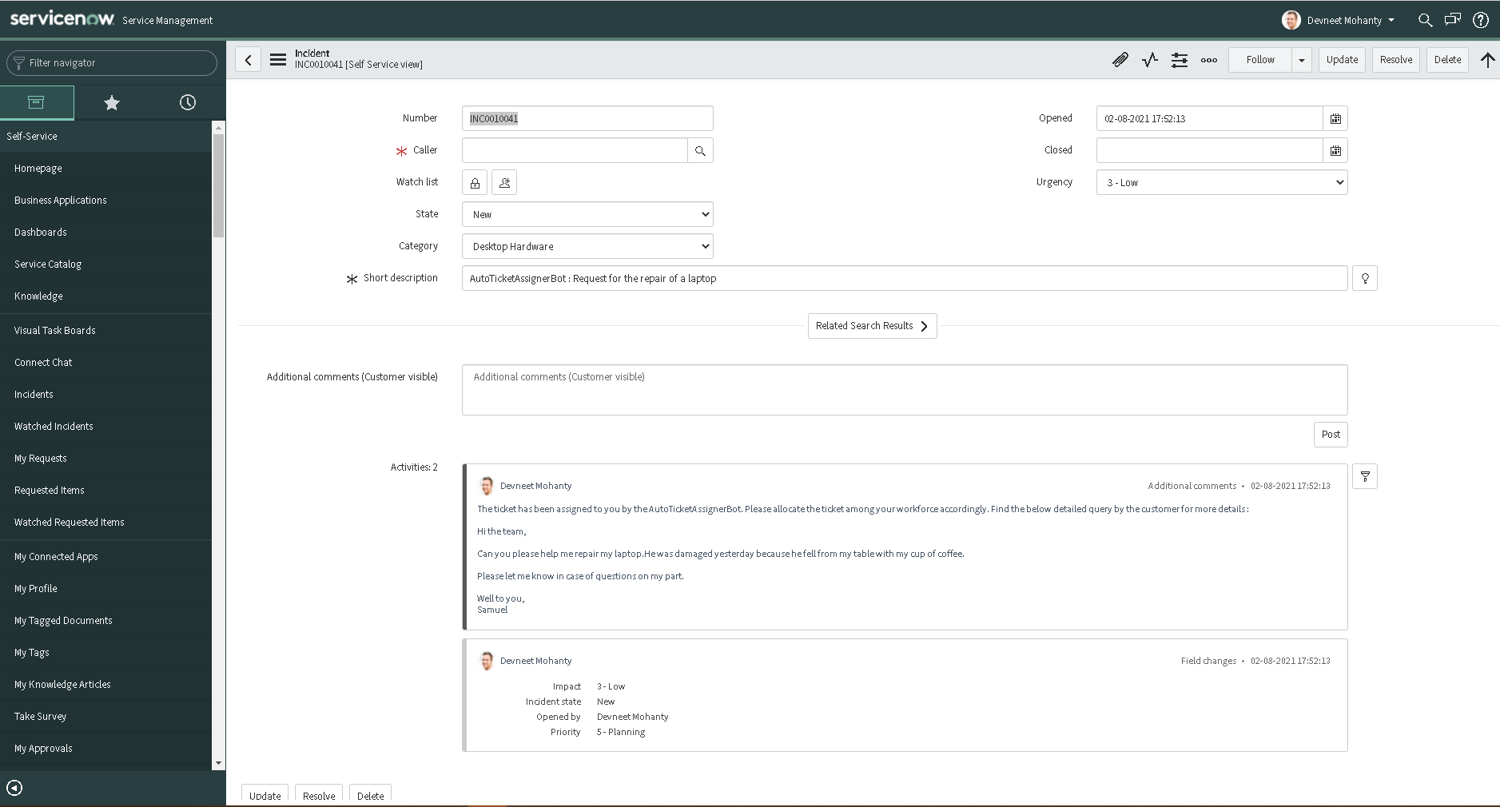

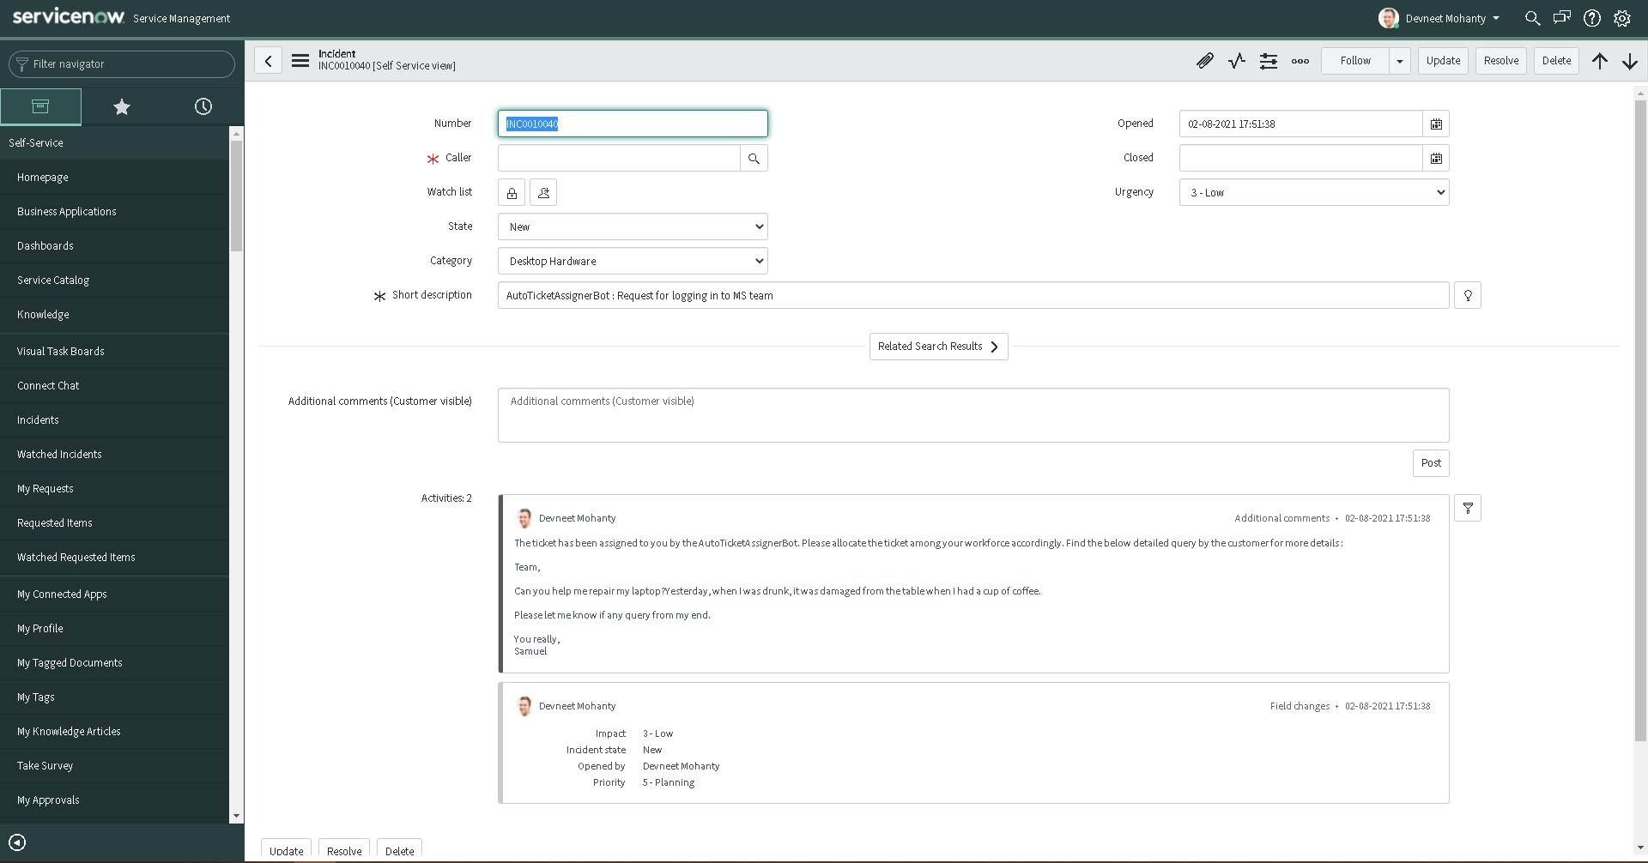

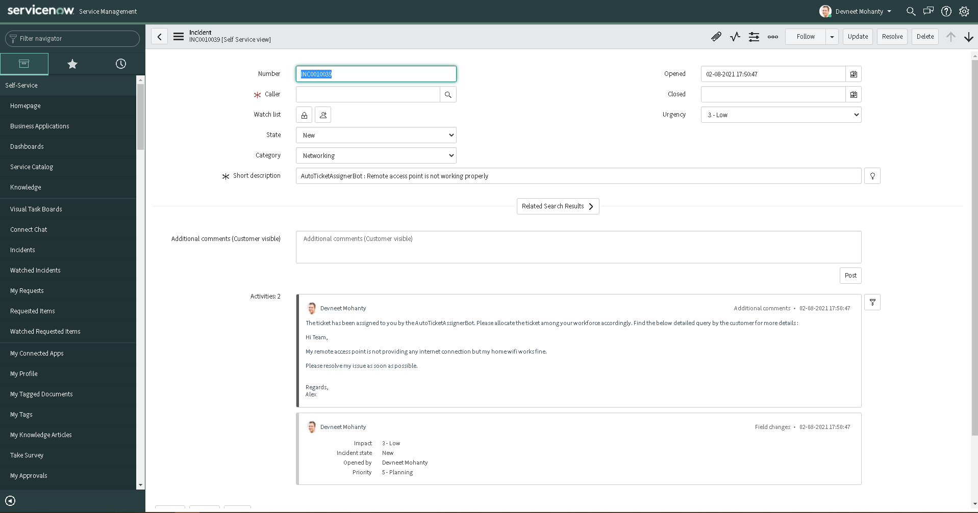

1. **Post Successful Run – Salesforce:**

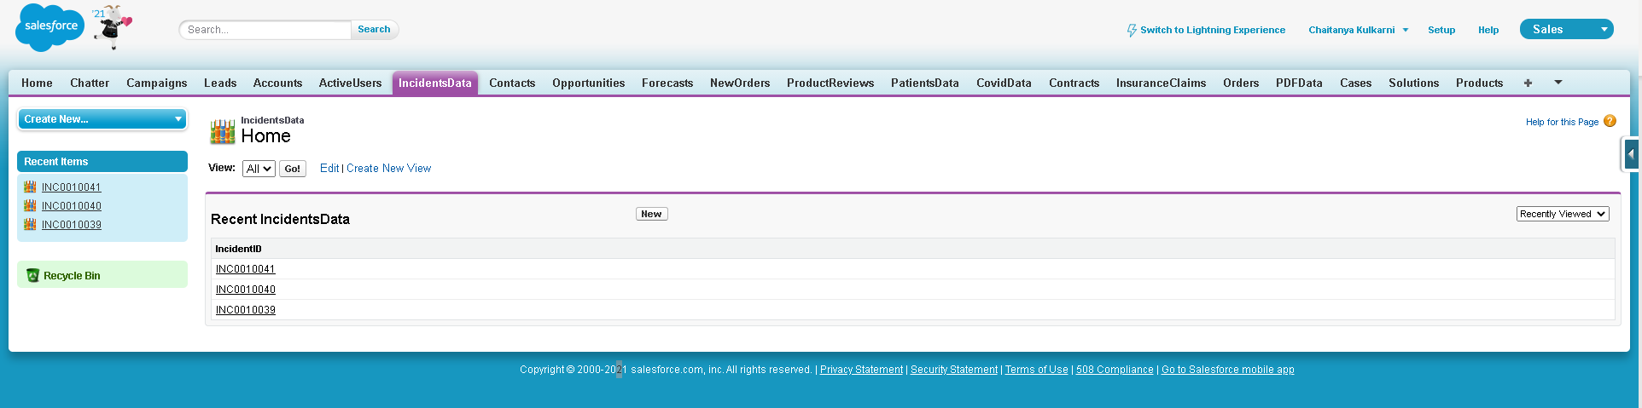

1. **Post Successful Run – Email Replies:**

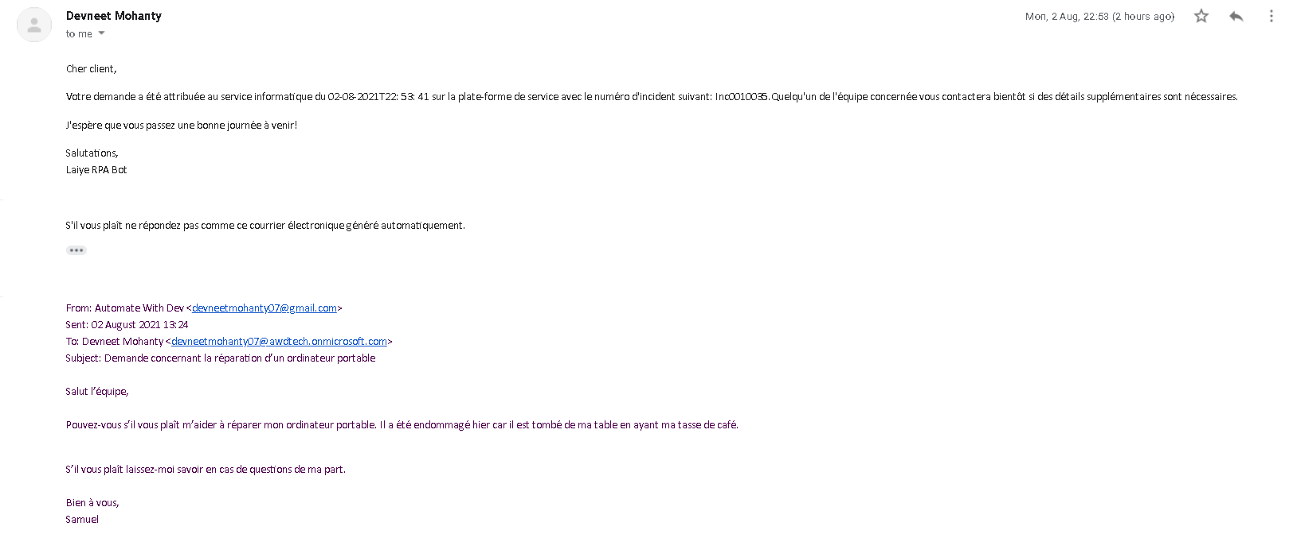

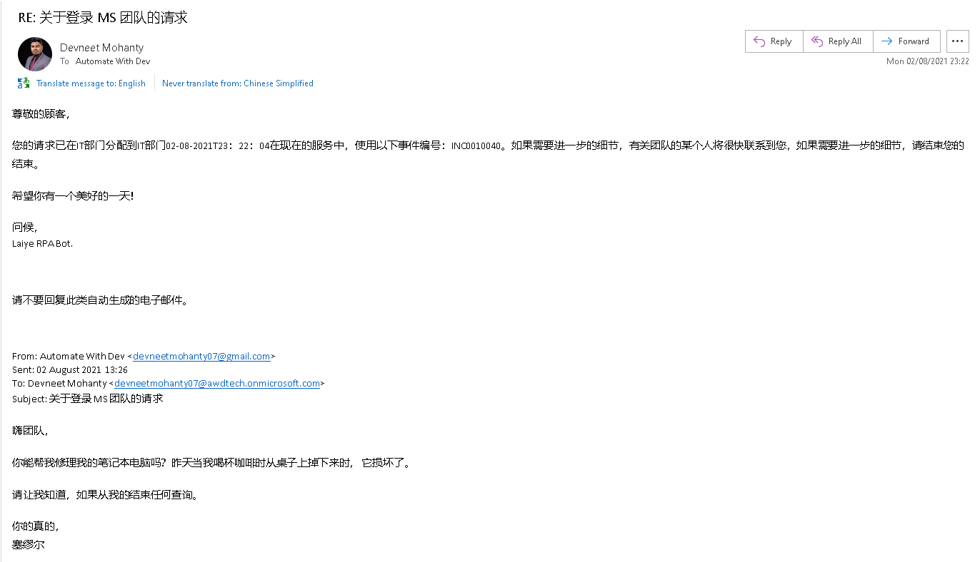

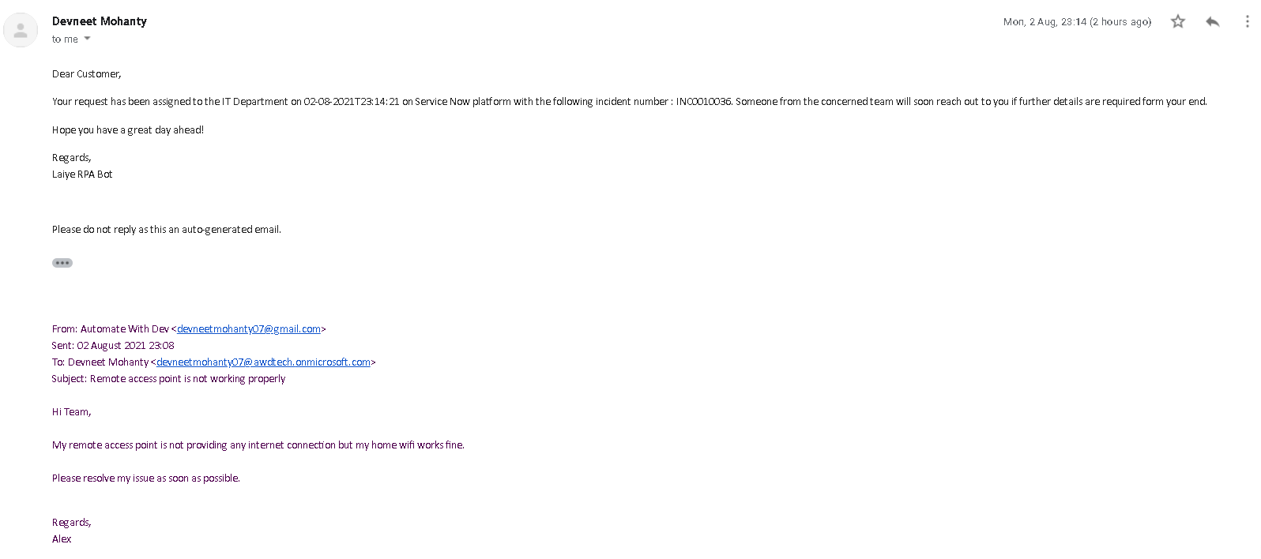

1. **Post Successful Run – Call Notification Log:**

